**SECURITY MANAGEMENT**

**PURPOSE**: TO ENSURE CORRECT ACCESS TO THE SERVER AND ITS OBJECTS (databases, jobs, tables, views, etc..) BY USING RELEVANT AUTHENTICATION MODES AND SECURITY PRINCIPALS.

**TYPES OF AUTHENTICATION MODES**:

**1. WINDOWS AUTHENTICATION MODE**

**WINDOWS** USERS / GROUP MEMBERS CAN CONNECT & USE SQL SERVERS.

**2. MIXED MODE**

WINDOWS USERS & **NON WINDOWS** USERS CAN CONNECT AND USE SQL SERVER.

**SECURITY OBJECTS**:

1. **LOGINS** : SECURITY OBJECTS USED TO ESTABLISH CONNECTION TO THE SERVER

2. **USERS** : SECURITY OBJECTS TO CONNECT AND OPERATE ON DATABASES, OBJECTS.

3. **ROLES** : TO GROUP MULTIPLE LOGINS & MULTIPLE USERS FOR COMMON PERMISSIONS

4. **SCHEMAS** : TO GROUP DATABASE OBJECTS (TABLEs,VIEW...) FOR COMMON PERMISSIONS

5. **KEYS** : DATABASE LEVEL SECURITY OBJECTS TO ENCRYPT (hide) DATA

6. **CERTIFICATES** : TO MAKE USE OF ABOVE KEYS AND PERFORM DATA ENCRYPTIONS.

7. **CREDENTIALS** : SERVER LEVEL SECURITY OBJECTS TO ESTABLISH SERVER CONNECTION

8. **PROXIES** : SQL AGENT LEVEL SECURITY OBJECTS TO ENFORCE JOB LEVEL SECURITY

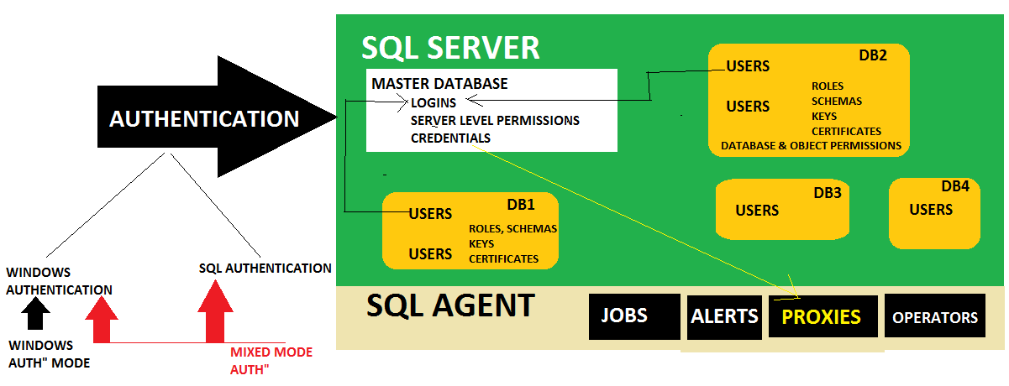

**PRACTICE ITEMS - SECURITY MANAGEMENT**

**ITEM #1: HOW TO VERIFY AUTHENTICATION MODE OF SQL SERVER (INSTANCE)?**

RIGHT CLICK SERVER > PROPERTIES > SECURITY > SERVER AUTHENTICATION .

**ITEM #2: HOW TO MODIFY AUTHENTICATION MODE FOR SQL SERVER (INSTANCE) LEVEL ?**

CHANGE TO WINDOWS AUTHENTICATION MODE:

RIGHT CLICK SERVER > PROPERTIES > SECURITY > WINDOWS AUTHENTICATION

RIGHT CLICK SERVER > **RESTART**.

CHANGE TO SQL SERVER AUTHENTICATION MODE:

STEP 1: RIGHT CLICK SERVER >> PROPERTIES >> SECURITY > SQL SERVER AUTHENTICATION

STEP 2: SERVER > SECURITY > LOGINS > RIGHT CLICK "**sa**" > PROPERTIES >> STATUS : ENABLE. GENERAL PAGE: SET PASSWORD > OK. RIGHT CLICK SERVER > **RESTART**.

**ITEM #3: WHAT IS PASSWORD POLICY (PASSWORD RULES) IN SQL SERVER?**

MINIMUM 8 CHARACTERS, EXPIRES EVERY 60 DAYS. USER CHANGE PASSWORD ON 1ST LOGIN.

**ITEM #4: HOW TO CREATE NEW WINDOWS LOGINS & USERS?**

STEP 1: WINDOWS CONTROL PANEL > (PC > MANAGE) > USER ACCOUNTS > CREATE USER

STEP 2: CONNECT TO SERVER > SERVER SECURITY > RIGHT CLICK > NEW LOGIN > SEARCH > SPECIFY WINDOWS USER /GROUP > CHECK NAMES >OK. SERVER ROLES,USER MAPPING

**ITEM #5: HOW TO CREATE NEW SQL LOGIN & SQL USERS?**

SERVER SECURITY > NEW LOGIN > SQL SERVER > PASSWORD, DEFAULT DATABASE, SET ROLES.

**ITEM #6: WHAT ARE THE SERVER ROLES (PREDEFINED FOR LOGIN LEVEL SECURITY MANAGEMENT) ?**

1. bulkadmin : Can perform Bulk Operations like Import/Export.

2. dbcreator : Can perform DDL operations on Database

3. diskadmin : Can perform Disk level Operations like Size Increase, Shrink..

4. processadmin : Can perform Auditing or Monitoring Operations

5. securityadmin : Security Management at Server Level : Logins, Server Roles...

6. serveradmin : Read & Write permissions for all databases in entire instance

7. setupadmin : Installation, Repairs, SP, Patch Operations

8. sysadmin : Complete permissions on entire server

9. PUBLIC : Default, For metadata access (Properties) of the server.

**ITEM #7: WHAT ARE THE DATABASE ROLES (PREDEFINED FOR USER LEVEL SECURITY MANAGEMENT) ?**

1. db_backupoperator : To perform Backups on the database

2. db_datareader : To perform SELECT & FETCH on current database

3. db_datawriter : To perform DML on the database

4. db_denydatareader : To Explicitly deny READ permissions on database

5. db_denydatawriter : To Explicitly deny WRITE permissions on database

6. db_securityadmin : To Perform Security Management at entire Database Level

7. db_ddladmin : To perform DDL operations on the database

8. db_owner : Complete permissions on entire database

9. db_accessadmin : Can provide Database connection to applications

10.PUBLIC : Default, For metadata access & properties of the database.

**ITEM #8: HOW TO TEST THE LOGIN?**

**CASE 1: TESTING SQL LOGINS**

LAUNCH SSMS > SPECIFY SERVER NAME. IN AUTHENTICATION : SELECT "SQL SERVER AUTHENTICATION" > SPECIFY LOGIN NAME AND PASSWORD > CONNECT

**CASE 2: TESTING WINDOWS LOGINS**

SIGN IN TO WINDOWS WITH REQURIED USER [EX: AMIN USER ABOVE].

SSMS > LUNCH SSMS > SERVER NAME. "WINDOWS AUTHENTICATION" > CONNECT.

**ITEM #9: HOW TO VERIFY OR AUDIT THE LOGIN NAME & USER NAME FOR A GIVEN CONNECTION?**

SELECT SUSER_NAME () -- TO REPORT SERVER LEVEL LOGIN INFORMATION

SELECT USER_NAME( ) -- TO REPORT DATABASE LEVEL USER INFORMATION